Water Purification

Subject:  Related Subjects: | Grade Level(s):  Length of Lesson: 60 Minutes + 15 Minutes Preparation Time | Type: Inquiry / Design / Project  Keywords:

Lesson Overview
Use this section to describe at a high level what the lesson is. Should be no more than 3-4 lines.

Lesson Focus
In this activity, students will build a water filter using materials found at their campsite and in their backpacks.

Lesson Objective(s) | By the end of this lesson, students will…  - Recognize that common materials can be used to create solutions for difficult problems  - Describe the difference between a physical filter (sand, coffee, filters, cotton) and a chemical filter (activated carbon)

Lesson Timing

5 minutes | Introduce the Lesson
30 minutes | ...

Materials | Materials:  Per individual  - ﻿﻿Clean This Water handout  - ﻿﻿pencils  - ﻿﻿gravel  - ﻿﻿sand  - ﻿﻿coffee filters  - ﻿﻿cotton balls or gauze  - ﻿﻿activated carbon (charcoal)  - ﻿﻿scraps of cotton and denim cloth  - ﻿﻿utility knives  - ﻿﻿scissors  - ﻿﻿Environmental Engineer career cards  - ﻿﻿1 plastic bottle (not included)  Per Class (dirty water)  - ﻿﻿2 gallon bucket filled with water  - ﻿﻿soy sauce (to represent chemicals)  - ﻿﻿dried beans (to represent animal/human waste  - ﻿﻿organic potting soil (to represent soil)  - ﻿﻿vegetable oil (to represent motor oil)  - ﻿﻿torn pieces of paper & styrofoam (to represent litter)
Instructor Prep | - Read the scenario to students.  - Your group needs clean water to drink and cook with, but the water pump at the campsite has broken due to the earthquake. There is a river, but water may contain pollutants. Cari, from SWE, mentioned mentioned that it may be possible to build your own water filter.  - Explain to the group that each student must design and build a water filter that can filter out all the water pollutants that may be in the river water.  - Lead a discussion with the students by asking them to imagine living in an area in the world that does not have access to clean water.  - How would your life be different without local access to clean water? (Some kids must walk long distances daily to fill their family’s water basins at a well or a stream, taking time away from school. Readily available clean water also reduces illness since we can wash ourselves and our food more easily. )  - Make the dirty river water in front of the students so they can see they need to filter out. As you add each item, read out what pollutant is represented by each item. See the materials list for the items that are needed to make dirty water.  - Show the students what materials they have at the campsite that might work for the water filter:  - Water bottles that each of the students had brought from home  - Coffee filters that the leaders brought to make coffee in the morning.  - Cotton balls or gauze from the first aid kit.  - Scraps of denim and cotton from clothing.  - Gravel and sand from the river bed.  - Charcoal ash from last night’s campfire.
Related Resources | 1.Discuss worldwide efforts to increase access to clean water:  The United Nations Millennium Development Goals are eight linked objectives set out by the UN in 2000 to combat worldwide poverty. One of the goals involves improving access to clean water.Discuss worldwide water issues and efforts to combat clean water shortages with your group.  Visit http://www.wagggsworld.org/en/take_action/gat/mdgs/mdg7 for ideas (from the World  Association of student Guides and student Scouts) or www.tapproject.org (from UNICEF).  2. Hold an event on World Water Day:  World Water Day occurs on March 22, with a different theme every year. Events are held around the world promoting the cause of increasing access to clean water. Find out more at:  http://www.worldwaterday.org.  3. Check out the innovative science behind harvesting water from fog at http://teachers.egf-k12.  org/lesson-water-from-fog.

Lesson Plan

Introduction

Most of the materials in the filter are acting as physical barriers to trap contaminants. Sand is a natural filter that can remove many impurities from the water, like dirt and oils. Having gravel below the sand keeps the sand in place and prevents it from clogging the openings at the bottom.

The activated charcoal, or carbon, is a chemical filter and removes smaller particles from the water. Activated carbon is a type of carbon that is very porous, and has an extremely large surface area, like a honeycomb. Because of this large surface area, the water flows over more carbon, providing many opportunities to be filtered. As the water flows through, smaller particles like lead and other chemicals are attracted to the pores in the carbon, and the particles are filtered out. Home water filtration systems, like Brita water filters, use activated carbon charcoal particles as well.

Activated carbon also has industrial uses. Carbon can be manufactured to have different pore sizes, to respond to the needs of the application. For example, it has been used to clean chemical spills from water sources,

Procedure

Cut at least one plastic bottle to make a filter as shown in the illustration on Clean this Water Handout, so that the students have an example of correctly cut bottle.
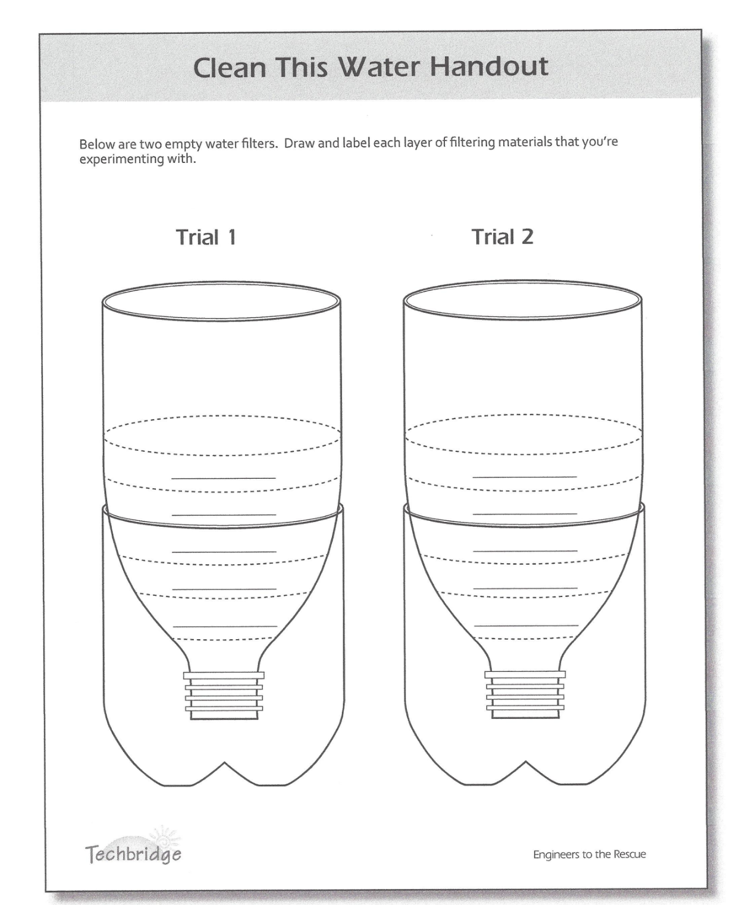

Set out filter materials.

Brainstorm. Each student will make own filter, but students should be encouraged to work in groups of two or three to brainstorm together. Allow the students to look at the different materials they can use and the bottle you cut before the session so that they can see how the materials can be layered in the top portion of the bottle.

Point out that charcoal can remove chemical substances from polluted water. Each student needs only two spoonfuls of charcoal.

Hand out the Environmental Engineer role model career cards. Ask for volunteer to read the entire card to the group, including “Here’s what I know” on the back.

Discuss, in groups, which materials they think will work best. Consider the following questions:

How will each material filter out the different parts of the dirty water?
Why is it necessary to use more than one material in the filter? (Different size materials help to fill in all nooks and crannies in the filter, making it more difficult for solids to pass through. )
Give each student a bottle diagram and a pencil to sketch her plan for the filter layers. Have the students clearly label each layer. Once the students have finished their design for their filter, have them check-in with you on their design.

﻿﻿﻿﻿Distribute a plastic bottle and a utility knife to each student to cut off the bottom half of the bottle or hand out the pre-cut bottles. The top half will be where the students will build their filter and the bottom half will catch the filtered water.
students can then gather and layer the materials for their filters.
﻿﻿﻿﻿Allow the group fifteen minutes to build their filters. Mingle and ask the students:
Note:
If your students enjoy competitions, have two or more students go up against each other to compare the results of their filters. We also suggest having the whole group start filtering at the same time, and at a designated time interval (say three seconds) have each student mark the water level on her bottle with a sharpie, then compare results.
- ﻿﻿What materials are you using and why?
- ﻿﻿What do you predict will happen?
Test the filters one at a time in front of the group and discuss the results.
﻿﻿﻿﻿Note. This water is drinkable, since there are no added chemicals to the organic potting soil.
Encourage the students to do a smell and taste test of their water as part of their evaluation.

Wrap-up
Discuss the results by asking the students questions about the differences they notice in the filters,
probing for the understanding that activated carbon is needed to filter out the "chemicals."
Lead a discussion using the following questions:
- ﻿﻿Which material seems more difficult to filter out?
- ﻿﻿Which materials seemed to work best for certain pollutants?
- ﻿﻿Why is it important that engineers and scientists are working in the area of water filtration?
- ﻿﻿Why is it important that common materials can be used to filter water?
Redesign (10 Minutes):
- ﻿﻿﻿﻿Redesign. Allow time for students to go back to their groups and redesign their filter, based on their findings. We recommend the following order: at the bottom of the filter, place a coffee filter, then charcoal, cotton, gravel, and sand. Compare the clarity and taste of the water of the redesigned filter to the first.
- ﻿﻿﻿﻿Discuss the following questions:
- ﻿﻿How did you improve your water filter after testing?
- ﻿﻿What were some lessons learned?
- ﻿﻿Do some materials filter better than others?

Lesson Background for Teachers

Suggested Real-World STEM Connections
- List possible related Role Models in STEM (with details and links to more reading). Give suggestions for examples of scientists/engineers who are from underrepresented groups in STEM in related careers.
- List related real-world engineering problems and examples

Lesson Variations and Options
Include descriptions of alternative methods or ways to present things.

Explanation
Describe the background concepts and explanations behind the lesson. This can be more in depth than a teacher/instructor would actually share with students.

Key Concepts and Vocabulary
- Word 1: Grade Appropriate Definition
- Word 2: Grade Appropriate Definition

Safety Notes
- Older students can use the utility knives to cut their own bottles, but the leader may choose to cut the bottles for the younger students. For safety , be sure to cut away from your body.

